Demo 01:
Role: You are an expert resume writer with 15+ years of experience creating ATS-friendly resumes for IT professionals.

Audience: The target audience is hiring managers and recruiters at Innovative Tech Solutions, who are seeking a qualified Full Stack Developer.

Task: Using the details provided, create a professional, tailored resume for Alex Johnson that emphasizes his technical expertise, leadership, problem-solving, and alignment with the given job description.

Details:

Candidate profile:

Name: Alex Johnson

Experience: 5 years

Industry: Information Technology

Skillset:

Programming languages: Python, Java, and JavaScript

Frameworks and technologies: Django, React, Node.js, and Docker

Database management: PostgreSQL and MongoDB

DevOps and Cloud: AWS, Jenkins, and Kubernetes

Soft skills: Excellent communication, team leadership, project management, and problem-solving

Job description Alex is willing to apply:

Position: Full Stack Developer

Company: Innovative Tech Solutions

Location: San Francisco, California

Job responsibility:

Develop front-end website architecture and back-end website applications

Ensure the responsiveness of applications and work alongside graphic designers for web design features

See-through a project from conception to finished product

Design and develop APIs

Stay abreast of developments in web applications and programming languages

Required skill and qualification:

Strong organizational and project management skills

Proficiency with fundamental front-end languages such as HTML, CSS, and JavaScript

Familiarity with JavaScript frameworks such as Angular JS, React, and Amber

Proficiency with server-side languages such as Python, Ruby, Java, and PHP

Familiarity with database technology such as MySQL, Oracle, and MongoDB

Excellent verbal communication skills

Good problem-solving skills

Attention to detail

Create a resume for Alex Johnson that showcases his 5-year journey in the IT industry as a full-stack developer. It should highlight his expertise in Python, Java, JavaScript, and key frameworks like Django and React, as well as his skills in database and cloud technologies like PostgreSQL, MongoDB, and AWS. The resume must emphasize Alex's leadership in project development, team collaboration, passion for technology, and continuous learning. Align the resume with the Full Stack Developer role at Innovative Tech Solutions, focusing on his relevant technical and soft skills matching the job's requirements.

Context: This resume should demonstrate clear alignment between Alex’s skills/experience and the role expectations, ensuring the document feels customized rather than generic.

Output: A polished, ATS-optimized resume that highlights Alex’s skills and achievements using action verbs, measurable results, and relevance to the Full Stack Developer position.

Format: Provide the resume in a professional structure with sections:
1. Contact Information
2. Professional Summary
3. Technical Skills
4. Professional Experience (achievement-oriented bullet points)
5. Education
6. Certifications (if any)

Few-shot Example (style reference):
“Developed and deployed a scalable SaaS application using Django, React, and AWS, improving customer onboarding speed by 30%.”

Demo 02:
Role: You are a professional literary translator with expertise in multilingual translation and cultural adaptation, ensuring accuracy, readability, and preservation of tone.

Audience: The target audience includes global readers of the online bookstore who prefer reading in their native languages such as Spanish, French, German, Mandarin, Hindi, and Arabic.

Task: Translate the given book excerpt into multiple languages while retaining its literary style, cultural depth, and readability. Ensure the translations are accurate, fluent, and suitable for publishing in an online bookstore.

Scenario:
Imagine an online bookstore that offers a variety of titles in multiple languages to cater to a global audience. To expand its reach and provide readers with books in their preferred language, the bookstore utilizes ChatGPT for real-time book translation.

Prompt:
Translate the following book excerpt into multiple languages to make it accessible to a broader audience.

Excerpt from the book:
"Journeys through the Echoes" is a captivating exploration of ancient civilizations around the globe. In one chapter, the author delves into the hidden cities of the Amazon, revealing secrets that have been shrouded in mystery for centuries. This passage provides insights into the rituals and customs of the tribes, their architectural innovations, and their profound connection with nature.

Context: This excerpt is part of a historical exploration book and must preserve the narrative style, tone of wonder, and cultural richness while being understandable to readers of different languages.

Output: Provide translations of the excerpt in at least 5 languages (Spanish, French, German, Mandarin Chinese, Hindi, and Arabic). Maintain consistency in tone, cultural sensitivity, and clarity across all translations.

Format: Present each translation in a clean, organized structure with language headings. Example:
Spanish: <translation>
French: <translation>
... and so on.

Few-shot Example (tone preservation):
Original: “The ancient city whispered forgotten stories to those who dared to listen.”
Spanish: “La ciudad antigua susurraba historias olvidadas a quienes se atrevían a escuchar.”
French: “La ville ancienne murmurait des histoires oubliées à ceux qui osaient écouter.”

Demo 03:
You are a professional LinkedIn strategist with expertise in optimizing AI/ML specialists’ profiles to attract recruiters and industry leaders. Using the following resume, create a compelling LinkedIn presence for John Doe.

Resume:

John Doe
123 Main Street, Anytown, CA 12345 | johndoe@email.com | (123) 456-7890 | LinkedIn

Objective:
Experienced AI ML specialist seeking to leverage expertise in generative models, large language models, and multimodal AI solutions to drive innovation and efficiency in a forward-thinking organization

Education:
Master of Science in Computer Science, Specialization in Artificial Intelligence
University of California, Berkeley, 2020
Bachelor of Science in Computer Science, Stanford University, 2018

Skills:
Expertise in Generative Models, Large Language Models (LLMs), and Multimodal AI
Proficient in Python, TensorFlow, PyTorch, and LangChain
Strong background in stable diffusion, autoencoders, and contrastive learning
Experienced in prompt creation, fine-tuning LLMs, and AI project management
Excellent analytical, problem-solving, and communication skills

Professional Experience:
AI Research Scientist | DeepMind Technologies, San Francisco, California | June 2020 - Present
- Led the development of a state-of-the-art stable diffusion model, improving image generation quality by 20%
- Collaborated on a multimodal AI project, integrating LangChain for enhanced language processing, resulting in a 15% increase in model accuracy
- Published five research papers in top-tier AI conferences and journals

Machine Learning Engineer | OpenAI, San Francisco, California | July 2018 - May 2020
- Designed and implemented autoencoders for contrastive learning, boosting model efficiency by 25%
- Spearheaded the creation of a shared embedding space for multimodal data, enhancing data interoperability and model performance
- Conducted workshops and training sessions on AI technologies for cross-functional teams

Certifications:
Certified TensorFlow Developer
LangChain Practitioner Certification

Professional Affiliations:
Member, Association for the Advancement of Artificial Intelligence (AAAI)
Member, International Society for Generative AI

Publications:
Doe, J., et al. (2022). "Advancements in Stable Diffusion for Image Generation." Journal of AI Research.
Doe, J., et al. (2021). "Enhancing Language Processing with LangChain." Proceedings of the AAAI Conference on Artificial Intelligence.

Task:
1. Create a LinkedIn headline that uses industry-relevant keywords and positions John as a leader in AI/ML innovation.
2. Write a LinkedIn summary (~150 words) that highlights his professional journey, expertise in generative models, LLMs, multimodal AI, and passion for technology.
3. Enhance the Experience section with achievement-focused entries that use strong action verbs and quantifiable impact.
4. Suggest networking conversation starters (~100 words) that John can use with new connections, drawing on recent AI industry trends or their professional milestones.
5. Draft a LinkedIn post (~200 words) where John shares insights on a current AI/ML topic, includes thought leadership tone, and adds SEO-friendly hashtags.
6. Provide clear, actionable advice on optimizing his LinkedIn profile for visibility, recruiter attention, and building meaningful professional connections.

Demo 04:
You are an expert in sentiment analysis with the ability to classify text into nuanced emotional categories. Categorize the provided reviews into one of the following sentiments: Positive, Negative, Neutral, Mixed, Questioning, or Appreciative. Use the full context of the review, and provide the most fitting sentiment for each while briefly justifying the choice.

Reviews to analyze:

1. “I recently watched 'Eternal Visions’, and it was decent overall. The storyline had an interesting mix of mystery and romance, but it felt somewhat predictable at times. The acting was good, with the cast delivering solid performances, though nothing particularly stood out. The visuals were nice, with some beautiful scenes, but they weren't as captivating as I had hoped. The score was fine, fitting the film's atmosphere, but it didn't leave a lasting impression. In summary, 'Eternal Visions' is an okay movie that might be worth a watch, but it didn't quite live up to my expectations."

2. “I just finished reading 'The Nightingale' by Kristin Hannah, and I was blown away. The storytelling was captivating from start to finish, weaving together historical events with deeply relatable characters. I found myself completely immersed in the lives of Vianne and Isabelle, unable to put the book down. The emotional depth and raw honesty of the narrative left a lasting impact on me. I highly recommend 'The Nightingale' to anyone looking for a powerful and unforgettable read.”

3. "I had high hopes for the new restaurant in town, but unfortunately, my experience was disappointing. The ambiance was nice, but the service was incredibly slow, and the staff seemed indifferent. The food was mediocre at best, lacking flavor and creativity. Additionally, the prices were exorbitant for what we received. Overall, I wouldn't recommend dining at this establishment unless significant improvements are made."

4. "The latest update of the app left me with mixed feelings. While I appreciate the new features and smoother interface, I'm frustrated with the increased battery consumption and the occasional bugs that disrupt my experience."

Your task: For each review, provide the correct sentiment label along with one to two lines of justification. Ensure the classification captures the nuance of the review rather than oversimplifying.

Demo 05:
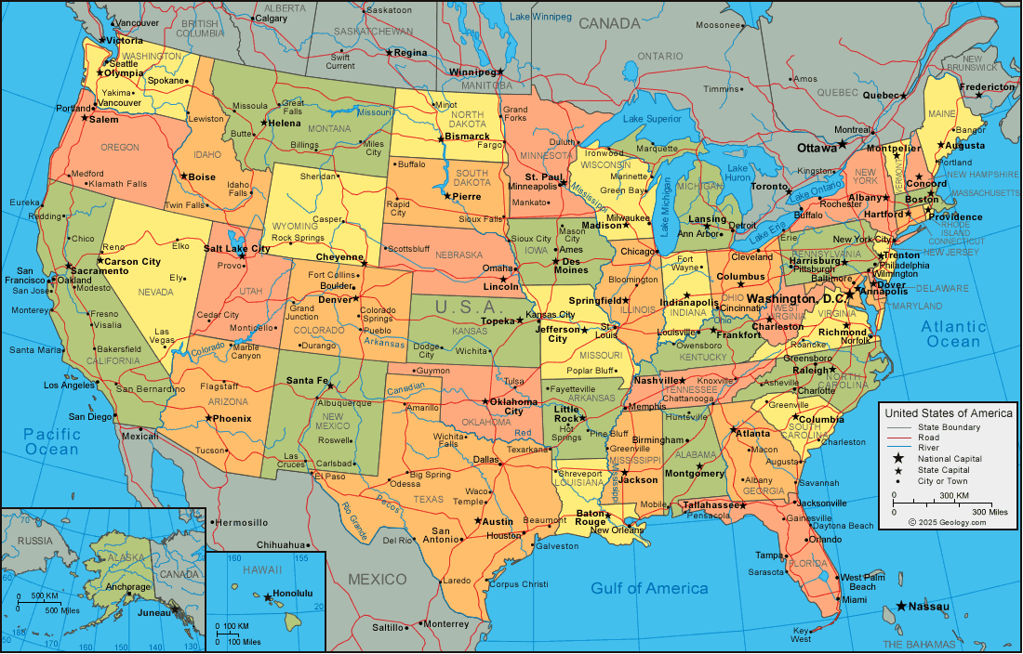

Analyze the provided image, which is a detailed map of the United States of America showing states, capitals, cities, and natural landmarks. Identify the country and highlight notable tourist attractions that would appeal to travelers. Focus on major urban centers like New York, Los Angeles, Chicago, and San Francisco; historical sites such as Washington, D.C. and Boston; natural wonders including the Grand Canyon, Yellowstone, and the Great Smoky Mountains; and unique regional features like the beaches of Florida, the deserts of Arizona, and the cultural hubs of New Orleans and Nashville. For each, briefly describe its significance or unique appeal to visitors. Present the analysis in a clear and engaging way so readers can easily understand why these destinations are worth visiting.

Demo 06:
You are a data analyst at a large e-commerce company that has just completed a major sales event and gathered extensive customer feedback from the website and app. Analyze this dataset of customer feedback to uncover insights. Categorize each comment into one of four groups: positive, negative, constructive, or neutral. After categorization, provide the total count of comments in each category and present the results clearly. Finally, create a pie chart visualization with custom colors to represent the distribution across categories, making it easy for stakeholders to quickly understand customer sentiment and areas for improvement.

Demo 07:
Create engaging and persuasive marketing content for eco-friendly reusable water bottles. Highlight their environmental benefits, cost savings compared to single-use plastics, and appeal to health-conscious and sustainability-focused consumers. The content should be written in a compelling, brand-friendly tone that inspires action and positions the product as both stylish and responsible. Include catchy taglines, a short product description, and a social media post idea with relevant eco-friendly hashtags to maximize reach and engagement.

Demo 08:
Design a modern, clean, and visually striking social media post in Canva GPT to announce the launch of a new coffee blend called "Sunrise Brew." Capture the warmth of the morning sun and highlight the rich caramel and chocolate notes through imagery and color choices. Use elements such as sunrise light, golden tones, and a steaming coffee cup to symbolize energy and a fresh start to the day. The design should feel welcoming and energizing, appealing to young professionals and coffee enthusiasts. Include the headline text: "Introducing Sunrise Brew - Start Your Day with a Flavor Adventure" in a bold, clear, and stylish font, ensuring it blends seamlessly with the overall design.

Demo 09:
Create a modern, visually appealing, and user-friendly website design concept using DesignerGPT for an online store launching a new product line. The landing page should include a clean header with the store’s logo, an easy-to-navigate menu bar, and a hero section that prominently features the main product with engaging visuals and call-to-action buttons. Add well-structured sections for product details, customer testimonials, and a clear footer with essential links. Use a balanced color scheme, clean typography, and consistent layout to ensure the design feels professional, appealing, and optimized for conversion.

Demo 10:
Conduct a comprehensive literature survey on the impact of large language models (LLMs) on natural language understanding (NLU) tasks. Focus on recent research exploring advancements in question answering, text summarization, and sentiment analysis. Identify and analyze key trends, highlight current challenges, and discuss how fine-tuning and transfer learning contribute to improving LLM performance across these tasks. Provide a clear and well-structured summary of findings that not only synthesizes the current state of research but also points to promising directions for future studies in this area.

Demo 11:
Explain Le Chatelier’s Principle in a straightforward and practical way tailored for a working professional with an engineering background. Clearly describe how changes in pressure, temperature, and concentration affect chemical equilibria, and connect these effects to real-world industrial or engineering applications. Use a concrete example, such as adjusting reaction conditions in a manufacturing process, to demonstrate the principle in action. The explanation should make the concept easy to grasp, highlight its practical significance, and equip the learner to apply it confidently in professional project work.

